5-minute demo
Tasks
1.
Prepare a 5-minute demo video or live walkthrough showing how you secured and monitored your cloud infrastructure, highlighting at least one security feature (like a firewall rule or IAM policy) and one monitoring dashboard (such as AWS CloudWatch or Azure Monitor).
2.
Review a peer’s cloud infrastructure presentation and provide written feedback covering: one thing they did well in security, one suggestion for improving their monitoring setup, and any questions you have about their implementation.<br><br><em><strong>Hint:</strong> Focus on practical aspects like clear access controls, alerting setup, or visibility of resource usage.</em>
3.
Update your cloud infrastructure based on feedback from your trainer or a peer — for example, add a missing security group rule or enable an additional monitoring metric — and document the change with before/after screenshots.
4.
Write a short reflection (5-6 sentences) describing one challenge you faced while securing or monitoring your cloud setup, how you solved it, and what you would do differently next time.

Answer : 1. Prepare your 5-minute demo
A simple demo structure:

Minute 0–1: Introduce your setup
Say/show:
- “I used AWS EC2 for my cloud infrastructure.”
- Show your EC2 instance.
- Briefly explain what the instance is used for.

Minute 1–2: Show the security feature
Use an EC2 Security Group.
For example:
- Allow SSH (port 22) only from your own IP address.
- Allow HTTP (port 80) if you are running a website.
- Avoid allowing SSH from 0.0.0.0/0 unless absolutely necessary.
Show the Inbound rules and explain:
“This security group controls which traffic can reach my EC2 instance. I restricted SSH access to my IP address to reduce unauthorized access.”
Take a screenshot of the rules.

Minute 2–4: Show monitoring
Open AWS CloudWatch.
Show a dashboard or EC2 monitoring metrics such as:
- CPU utilization
- Network traffic
- Disk-related metrics where available
- Status checks
Explain something like:
“CloudWatch allows me to monitor the health and performance of my EC2 instance. I can use these metrics to identify unusual resource usage or possible problems.”
If possible, create a simple CloudWatch alarm for high CPU usage, such as CPU above 80%.

Minute 4–5: Summarize
Finish with:
- What security control you used
- What you monitor
- Why monitoring is important
- What you would improve in the future
Tip: Record your screen using OBS Studio, PowerPoint screen recording, or another screen recorder. You don't need a fancy video—clear screenshots and explanations are enough.

2. Review your peer's presentation
Your feedback needs three things:

A. One thing they did well
Look for:
- Strong IAM permissions
- Restricted security-group rules
- MFA
- Good firewall configuration
- Clear separation of users/roles
Example:
“One thing you did well was restricting access to your cloud resources. Your use of IAM roles helps prevent unnecessary permissions.”

B. One monitoring improvement
Look for whether they have:
- CloudWatch/Azure Monitor
- CPU monitoring
- Network monitoring
- Alerts
- Logs
- Notifications
Example:
“I suggest adding a CloudWatch alarm for high CPU utilization. This would provide an early warning if the server becomes overloaded.”

C. Ask a question
Example questions:
- “How would you detect an unauthorized login?”
- “Did you configure alerts for unusual CPU or network usage?”
- “Why did you choose these particular IAM permissions?”
- “What would happen if the server's CPU reached 100%?”

3. Update your infrastructure based on feedback
This part is basically before → change → after.
For example, suppose your peer says:
“You should add monitoring for high CPU usage.”
You can make that your improvement.

Before
Take a screenshot showing that you don't have a CPU alarm.

Make the change
In CloudWatch:
- Open CloudWatch.
- Go to Alarms.
- Choose Create alarm.
- Select your EC2 CPU utilization metric.
- Set a threshold, for example CPU > 80%.
- Configure a notification if required.
- Create the alarm.
After
Take another screenshot showing the new alarm.
Your documentation can explain:
Before: The EC2 instance did not have a CPU utilization alarm.
Change: I created a CloudWatch alarm for CPU utilization above 80%.
After: The alarm now provides an alert when CPU usage becomes unusually high.
This gives you very clear evidence that you actually implemented feedback.

4. Write your 5–6 sentence reflection
Your reflection should follow this simple pattern:
- Challenge: What was difficult?
- Problem: What specifically went wrong/confused you?
- Solution: How did you fix it?
- Result: What happened after the fix?
- Lesson: What did you learn?
- Next time: What would you do differently?
For example:
Cloud Infrastructure Reflection
One challenge I faced was configuring my cloud security rules without giving users unnecessary access. I initially found it difficult to understand which ports should be open and which should remain restricted. I solved this by reviewing the security group rules and allowing only the traffic required for my application. I also configured CloudWatch monitoring so I could see the EC2 instance's resource usage and receive an alert when CPU usage became too high. This helped me understand that security controls and monitoring should work together to protect and maintain cloud resources. Next time, I would configure monitoring and alerts earlier so that I could detect potential problems while setting up the infrastructure.

Simple checklist for the whole assignment
- Create/identify your AWS EC2 infrastructure.
- Configure a Security Group.
- Take a screenshot of the security rule.
- Open CloudWatch.
- Show CPU/resource monitoring.
- Create a useful CloudWatch alarm.
- Record your 5-minute demo.
- Watch/review your peer's presentation.
- Give one security strength.
- Give one monitoring suggestion.
- Ask at least one implementation question.
- Apply feedback to your infrastructure.
- Take before and after screenshots.
- Write your 5–6 sentence reflection.

1. Security Group — your security feature
An EC2 Security Group works like a virtual firewall: it controls incoming and outgoing traffic to your instance. AAWS Documentation
Here is an example of the Inbound Rules screen:
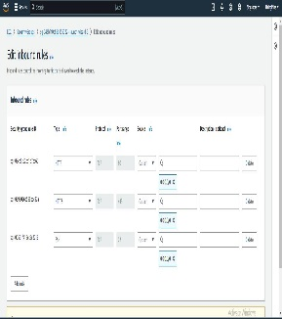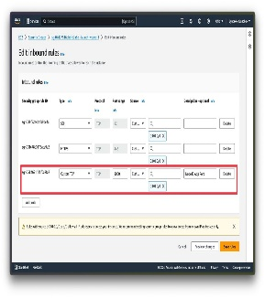

A good beginner setup
For example:
Type | Port | Source | Purpose
SSH | 22 | My IP | Secure server access
HTTP | 80 | Anywhere | Website
HTTPS | 443 | Anywhere | Secure website
Important: For SSH, use My IP rather than 0.0.0.0/0 when possible. AWS specifically recommends restricting SSH access to the IP addresses that need it. AAWS Documentation

What you can say in your video
“This is my EC2 security group. I configured SSH access to only my IP address, which reduces the risk of unauthorized access. I also allowed HTTP traffic because my application needs web access.”

2. CloudWatch — your monitoring dashboard
Next, open AWS CloudWatch → Metrics → EC2.
You should see metrics such as CPU utilization and other EC2 performance information.
Here's an example:
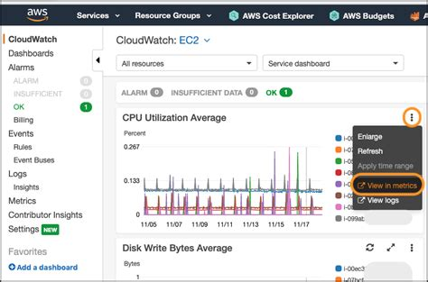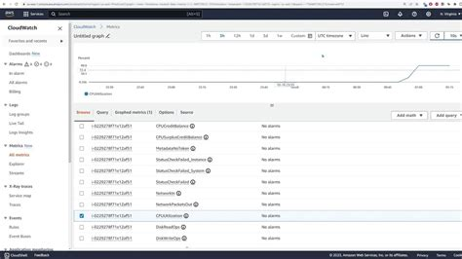

What to look for
Your dashboard might show something like:
CPU Utilization
0% ──────── 20% ──────── 40% ──────── 80%
Then a graph showing how CPU usage changes over time.
You can say:
“This CloudWatch dashboard allows me to monitor my EC2 instance. I'm monitoring CPU utilization to make sure the server is not experiencing unusually high resource usage.”
CloudWatch can also use alarms to notify you when a metric passes a threshold. For example, you could create an alarm when CPU utilization stays above 80%.

3. Example of your 5-minute demo
You can follow this exact order:

🕐 0:00–1:00 — EC2
Show your EC2 instance.
Say:
“This is my AWS EC2 instance. It provides the computing environment for my cloud application.”

🕐 1:00–2:00 — Security
Go to:
EC2 → Security Groups → Your Security Group → Inbound rules
Show your rules.
Say:
“My main security feature is the EC2 Security Group. It works as a virtual firewall. SSH is restricted to my IP address, while HTTP is allowed for web traffic.”

🕐 2:00–4:00 — Monitoring
Go to:
CloudWatch → Metrics → EC2 → CPU Utilization
Show your graph.
Say:
“I'm using CloudWatch to monitor my EC2 instance. The main metric I'm watching is CPU utilization. This helps me identify performance problems.”

🕐 4:00–5:00 — Alarm + conclusion
Show your CloudWatch alarm if you created one.
Say:
“I also configured an alarm for high CPU utilization. If CPU usage becomes too high, the alarm can notify me. This gives me both security and visibility into my cloud infrastructure.”

4. Peer feedback example
Imagine your classmate showed an EC2 server with a security group.
You could give them:
Security — something they did well
“One thing you did well was restricting SSH access instead of allowing access from every IP address. This is a good security practice.”
Monitoring — suggestion
“I suggest adding a CloudWatch alarm for high CPU utilization. This would make it easier to detect performance problems.”
Question
“How would you know if someone was attempting unauthorized access to your EC2 instance?”

5. Before/After example
This is probably the easiest way to complete Task 3.
BEFORE 📸
Take a screenshot of CloudWatch showing:
No CPU alarm configured.

CHANGE 🔧
Create:
CloudWatch → Alarm → EC2 CPU Utilization → Greater than 80%

AFTER 📸
Take a screenshot showing:
EC2-High-CPU-Alarm — OK
Then explain:
“Based on peer feedback, I added a CloudWatch CPU utilization alarm. Before the change, I did not have an alert for high CPU usage. After the change, CloudWatch can alert me when CPU utilization exceeds my selected threshold.”

6. What screenshots you should collect
You really only need about 5 screenshots:
Screenshot 1: EC2 instance
Screenshot 2: Security Group inbound rules
Screenshot 3: CloudWatch CPU graph
Screenshot 4: Before adding your improvement
Screenshot 5: After adding your improvement/alarm
That gives you evidence for all four tasks.

